# JedisGetStep

**Objective:**

It is used to retrieve the key value pairs in the redis server using Jedis client.

**Attributes:**

|  |  |
| --- | --- |
| **Attributes** | **Description** |
| value_type | To select type as free marker template or handlebar |
| data_type | To select which type of data need to enter. Ex: List, Set, HashMap and String. |
| key | To enter the key to get the respective value |
| output_variable | Used to store the response of the request |
| plugin_name | To connect with redis server based on the plugin credentials |

**Sample config.json:**

{

"workflows": [

{

"name": "jedis-get",

"id": 200,

"trigger": "rest",

"expression": "jedis-get",

"method": "GET",

"steps": [

{

"type": "start",

"id": 1,

"next": {

"start": "start"

}

},

{

"value_type": "ftl",

"data_type": "String",To connect with redis server based on the plugin credentialsTo connect with redis server based on the plugin credentials

"key": "address",

"output_variable": "getelement",

"plugin_name": "jedis-get",

"type": "jedis-get",

"id": "start",

"next": {

"success": "jedis-get-success",

"failure": "hangup"

}

},

{

"variable_name": "getelement",

"http_response_code": "200",

"response_content_type": "text/html",

"value_type": "hb",

"type": "send",

"id": "jedis-get-success",

"next": {

"success": "hangup",

"failure": "hangup"

}

}

]

}

],

"filters": [],

"server": {},

"plugins": [

{

"id": 24,

"name": "jedis-get",

"host": "localhost",

"port": "6379",

"type": "jedis-plugin",

"version": "1.0",

"category": "jedis"

}

]

}

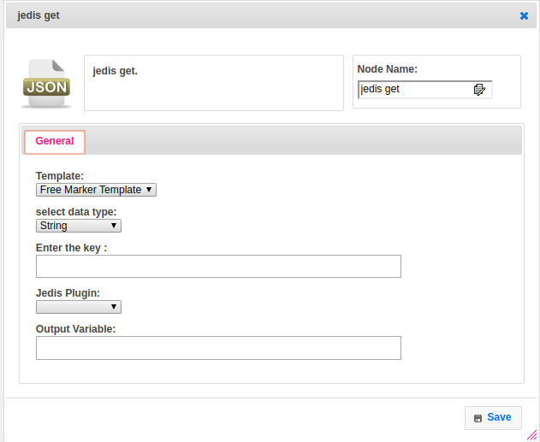

**Executor Description:**

In executor class first it will connect to redis server by using Redis Plugin Handler based on host and port values and Execute the respective jedis client method to retrieve the data based on type of data provided, For each data type have respective methods to store data. But as of write now we are supporting String data type only. Put the all data into output variable.